Project report

Overview
In this project an enhanced Convolutional Neural Network (CNN) and a baseline fully connected network are used to examine image classification performance. Comparing model architectures and examining how CNN-specific design decisions enhance image data performance are the objectives.

2. Description and Rationale of the Dataset
For this project, the CIFAR-10 dataset was chosen. It has 60,000 32x32 pixel RGB images spread across ten object classes:
- airplane
- automobile
- bird
- cat
- deer
- dog
- frog
- horse
- ship
- truck
In computer vision research, CIFAR-10 is a commonly utilized benchmark dataset. It is appropriate for assessing classification schemes due to:
- It includes a variety of object categories.
- It depicts real-world pictures.
- CNN architectures and baseline models are frequently compared with it.
Before training, the dataset was normalized to the [0,1] range.
Structures
The Multi-Layer Perceptron (MLP) used as the baseline model is made up of:
- Flatten layer
- Dense layer (256 units, ReLU activation)
- Dropout layer
Output layer (10 units, Softmax activation)
This model does not specifically take advantage of spatial structure in images because it does not employ convolutional layers.
Outcomes:
Test Accuracy
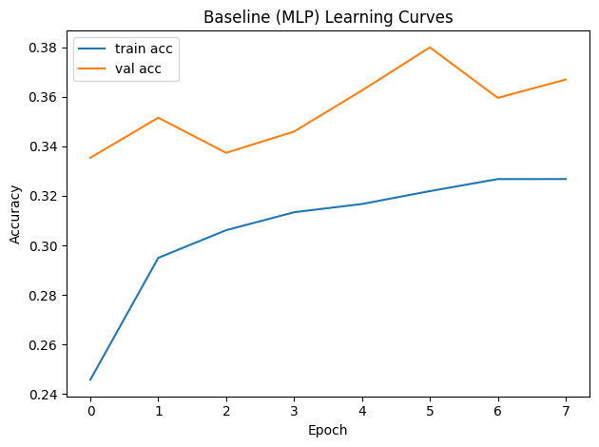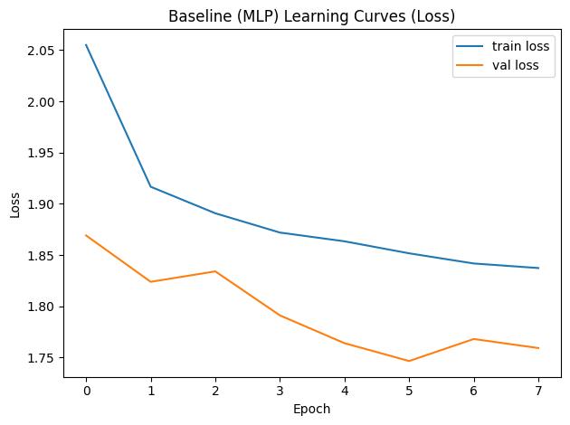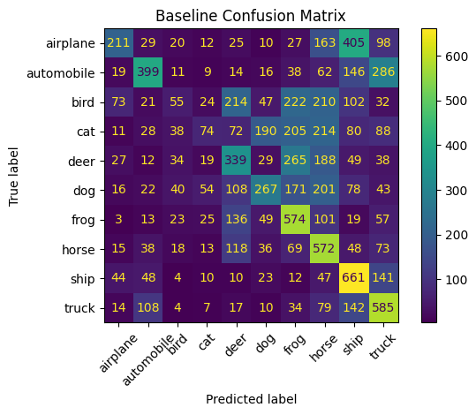
Although the baseline model's accuracy was moderate, it had obvious flaws. The model eliminates the spatial relationships between adjacent pixels by flattening the image into a 1D vector. This restricts its capacity to identify local characteristics like edges or textures.
The learning curves show that the baseline model exhibits:
- little progress over previous eras
- Underfitting symptoms
- Limited capacity for representation

Improved CNN Model
- Architecture
- The improved CNN includes:
- Data augmentation (random flip, rotation, zoom)
- Three convolutional blocks
- Batch Normalization
- ReLU activations
- Max pooling layers
- Fully connected layer
- Dropout
- SoftMax output layer
The network can learn hierarchical feature representations thanks to this architecture.

CNN is better for images because on image tasks, convolutional neural networks perform better than fully connected networks for the following reasons:
- They preserve spatial structure.
- Convolution filters detect local patterns.
- Weight sharing reduces the number of parameters.
- Pooling provides translation invariance.
- Batch normalization stabilizes training.
- Dropout reduces overfitting.

Data augmentation techniques used:
- Random horizontal flipping
- Random rotation
- Random zoom
By keeping the model from learning particular image patterns, augmentation improves generalization while increasing dataset variability.

CNN Results
Test Accuracy:
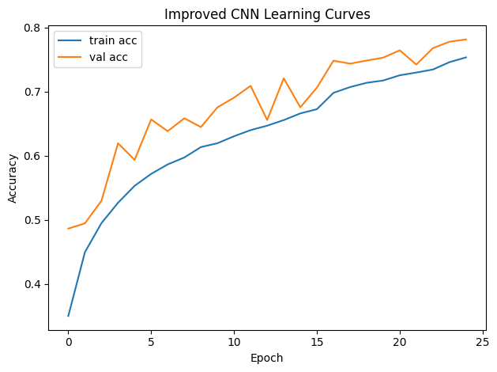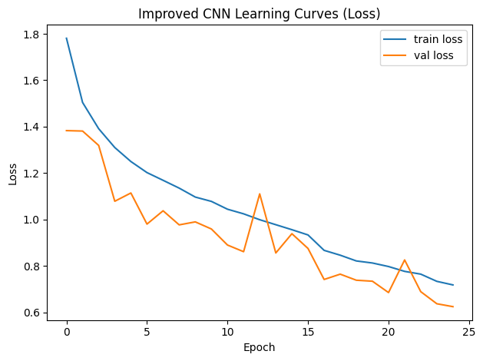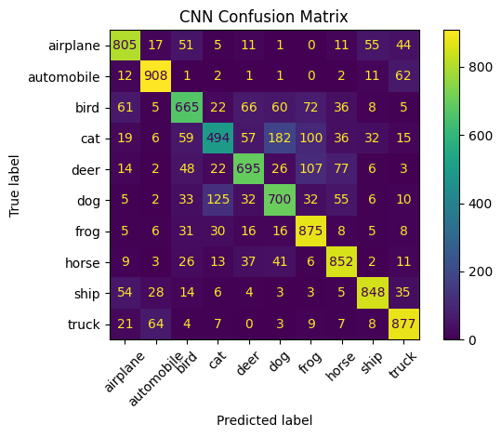

Quantitative Comparison
- Baseline Accuracy: 0.3823
- CNN Accuracy: 0.7719
- Absolute Improvement: 0.3896
The CNN significantly outperformed the baseline model, demonstrating the importance of convolutional feature extraction for image classification tasks.

The learning curves demonstrate:
- Compared to the baseline model, the CNN converges more successfully.
- Accuracy in training and validation rises steadily.
- Reasonable generalization is indicated by the close relationship between validation and training performance.
- Overfitting is avoided by stopping early.
- The CNN exhibits better optimization behavior and increased stability when compared to the baseline model.

Confusion Matrix Analysis
The confusion matrix reveals that certain classes are more frequently misclassified.
Common confusion patterns include:
- Cat vs Dog (similar visual structure)
- Deer vs Horse (similar shapes and posture)
- Ship vs Airplane (background similarity)
The low resolution (32×32) of CIFAR-10 images makes it challenging to make fine-grained distinctions, which leads to these errors.

Failure cases typically occur due to:
- Low image resolution limiting feature detail.
- Visually similar object categories.
- Complex backgrounds.
- Partial occlusion.
- Ambiguous object orientation.
The model misclassified airplane as a bird due to similarity in looks and low-resolution.

conclusion
For image classification tasks, this project shows that convolutional neural networks perform noticeably better than fully connected networks.
The CNN successfully learns hierarchical feature representations, whereas the baseline MLP struggles because it disregards spatial structure. Generalization is further enhanced by regularization and augmentation.
The findings support the notion that visual recognition problems are better suited for CNN-based architectures.

